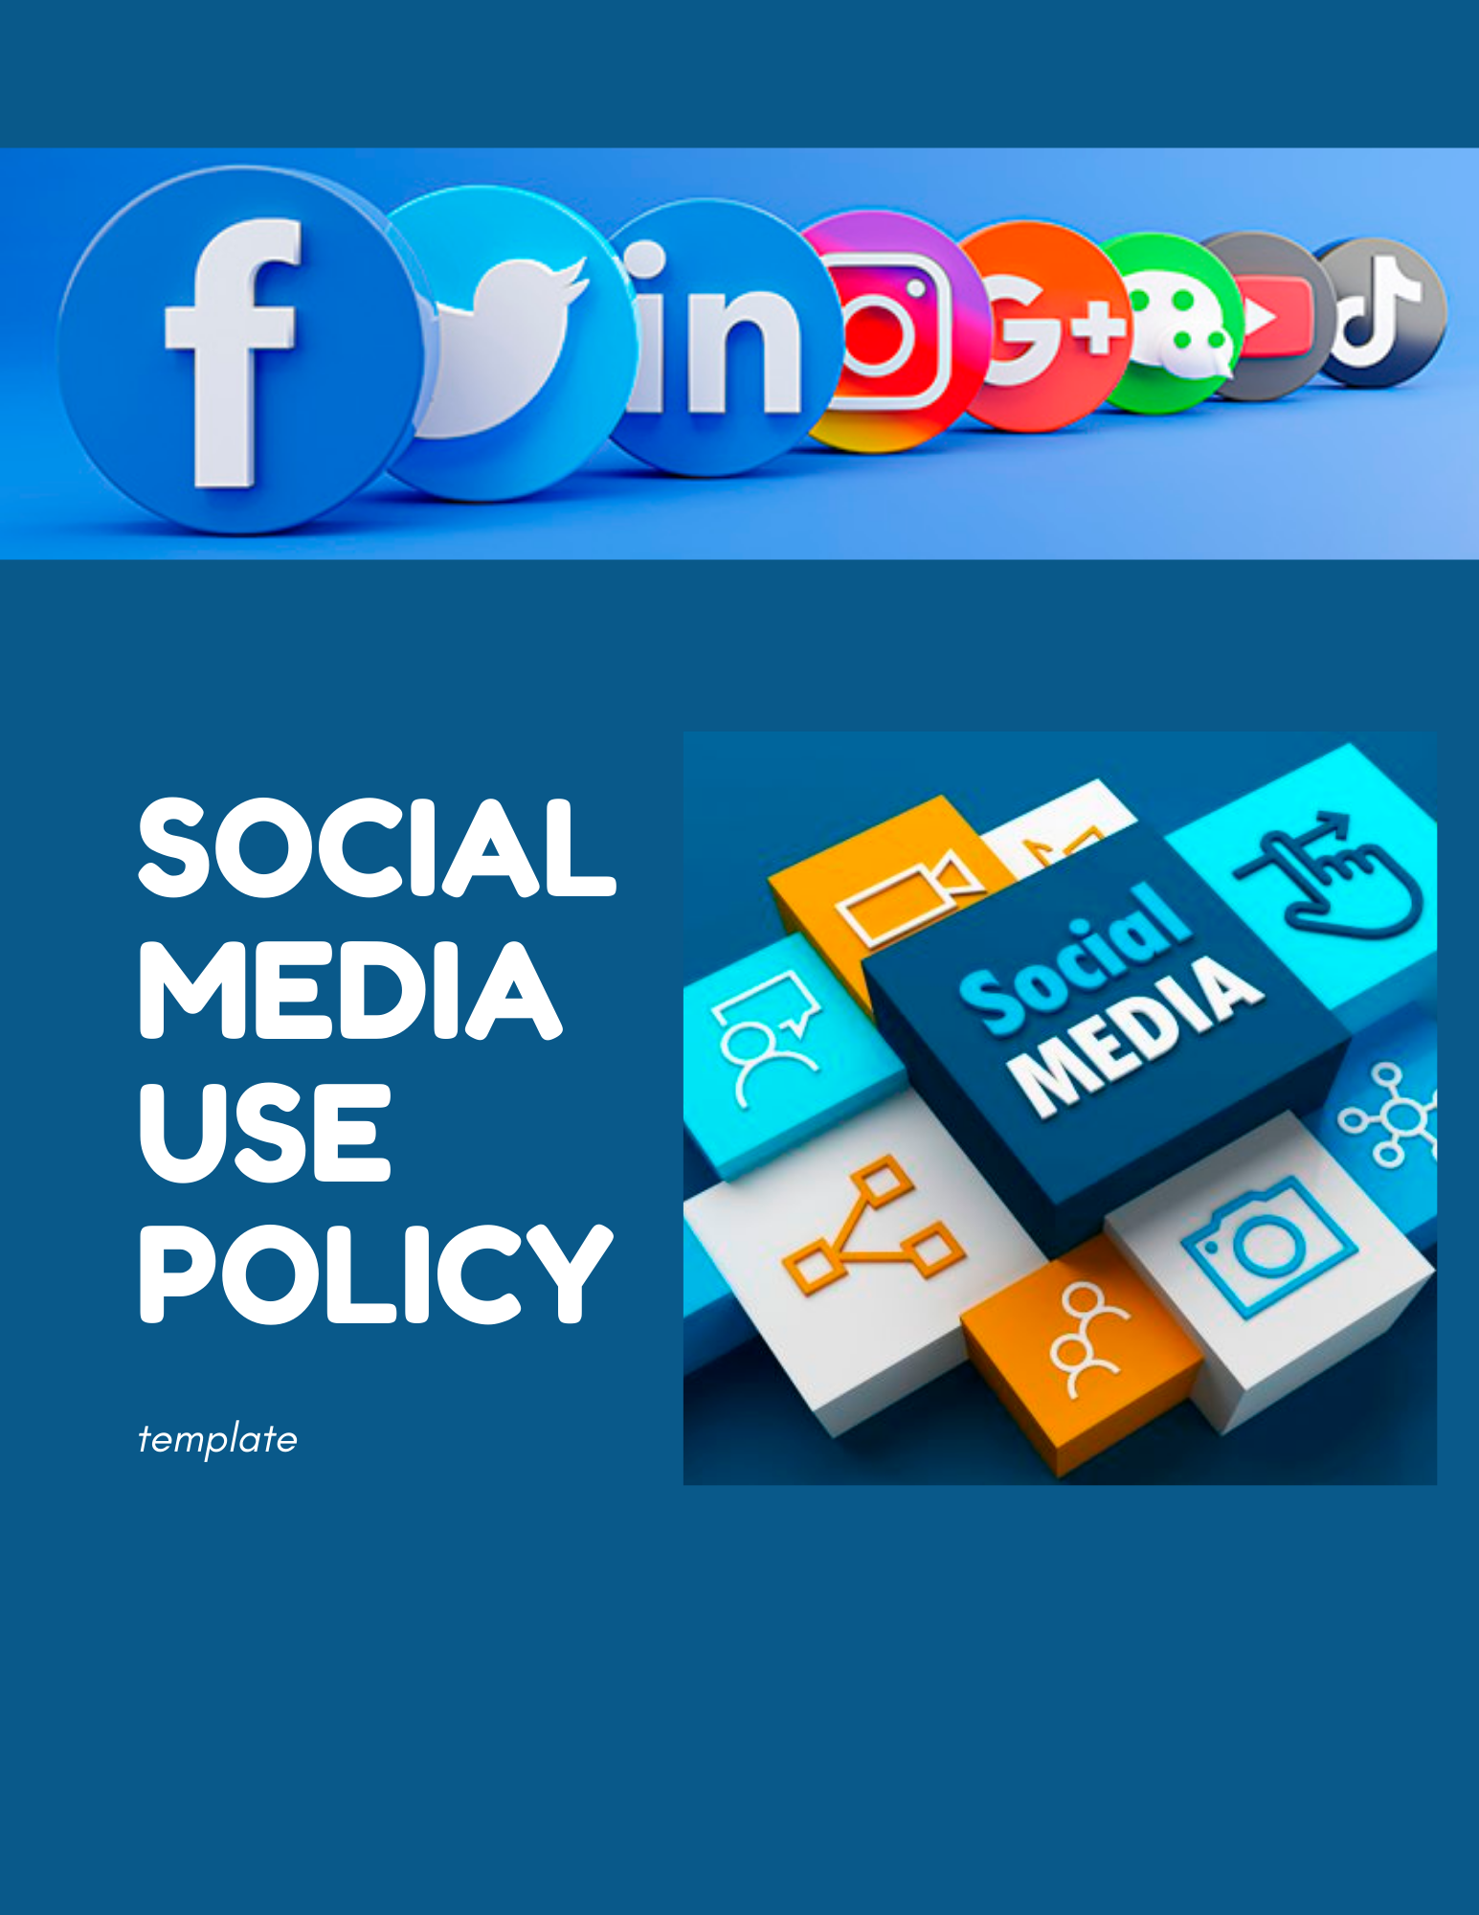

POLICY STATEMENT

[Insert Company Name] (“Insert Acronym If Applicable”) recognizes that social media (as defined below) offers exciting opportunities to express creativity, share knowledge, build a sense of community, and engage in conversations with others.

Employees engaging in social media are expected to be respectful, responsible, and demonstrate good judgment. Remember that you are responsible for what you say or post online.

[Insert Company Name]’s social media policy provides guidelines for the appropriate use of both work-related and personal social media. [Insert Company Name] expects all employees to engage respectfully in social media exchanges and conduct themselves in accordance with the [Insert Company Name] Code of Conduct and any other relevant policies, practices, guidelines and laws.

Misuse of social media can, in certain circumstances, lead to legal action being taken against employees or [Insert Company Name], lead to workplace investigations or discipline, or even constitute a criminal offence.

DEFINITIONS

For the purposes of this policy, the following terms are defined:

Supervisor

A person who has charge of a workplace or authority over an employee. Generally, this would include those with a position title such as Director, Manager or Supervisor, as well as any other management-type position, or those in a temporary supervisory position.

Employee

Refers to any person regarding whom [Insert Company Name] pays wages or a salary, has control over their assigned work and has a right to control the details of their work. It also extends to the senior management level employees.

This includes, but is not limited to:

a. full-time employees

b. part-time employees

c. seasonal employees

d. contract employees

e. any other individuals who are considered employees under the Ontario Employment Standards Act, 2000 (the “ESA”)

Social Media

Common examples of social media include Facebook, Instagram, LinkedIn, Twitter, email, chat rooms and YouTube, and work-related communications, including emails, telephone calls, video calls or sending or reviewing other messages.

GUIDELINES FOR RESPONSIBLE USE OF SOCIAL MEDIA

*Company Social Media Accounts and Online Interactions*

Employees are not permitted to use [Insert Company Name]’s official social media accounts or represent [Insert Company Name] online in any way unless specifically authorized in writing.

Employees who are authorized to use official social media accounts or represent [Insert Company Name] online in any way must follow these guidelines:

1. Be respectful and polite.
2. Avoid making promises. Always offer to contact a customer or client directly by phone or email.
3. Do not answer questions outside your area of expertise.
4. Do not disclose any confidential or proprietary information.
5. Do not make derogatory comments about competitors or other third- parties.
6. Do not post anything which is or could be construed as harassment or discrimination or which may include racial slurs, derogatory remarks, stereotypes, jokes, offensive visuals based on race, national origin, age, disability, marital status or other legally protected classifications.
7. Do not discuss any activities that occur in the workplace that would in any way portray a negative work environment (ex. complaining about a co-worker).

*Use of Social Media in the Workplace*

Employees are prohibited from using company-issued equipment such as laptops, desktops, and mobile phones to access personal social media accounts. The use of company devices when accessing social media is limited to employment functions and must be within the scope of an employee’s duties.

*Personal Social Media Activity*

While the activities of employees' personal time and devices are their responsibility, as representatives of [Insert Company Name], employees are expected to behave in a manner consistent with the [Insert Company Name] Code of Conduct when using personal social media accounts and interacting with others online.

If an employee includes information about their position at [Insert Company Name] in the profile or content of their personal social media page, they must include a disclaimer that says that their opinions and comments do not necessarily reflect the point of view of [Insert Company Name] or its management.

The following guidelines apply to the personal use of social media:

* Posted content must not violate any laws or encourage or suggest illegal activity.
* Users must comply with the terms of use established by the social media platform you are using.
* Do not post comments or material that may be considered racist, hateful, sexist, homophobic, defamatory, abusive or threatening, humiliating or rude.
* Never disclose sensitive, private or confidential information on social media.
* Make sure the information you are posting on social media is accurate.
* Make use of social media on your own time and with your own resources.
* Do not post aggressive, vulgar, violent, obscene or pornographic content.
* Do not post comments containing controversial opinions on politics, religion or other sensitive issues.

POLICY VIOLATIONS

Where an employee believes there is a violation by any employee, including themselves, the employee must immediately report this to their supervisor.

Online conduct may result in disciplinary action, up to and including termination, if it:

* adversely affects an employee’s job performance or the performance of colleagues
* adversely affects customer or third-party suppliers
* harms [Insert Company Name]’s products or reputation
* breaches the Criminal Code, human rights legislation, or any other laws
* interferes with the ability of [Insert Company Name] to carry out business or operational activities

Subject to applicable law, personal online activity that violates [Insert Company Name]’s Social Media Policy, Code of Conduct or any other internal policy may subject an employee to disciplinary action, up to and including termination.

Note

This policy is subject to amendment and/or revocation at the company's sole discretion, without prior notice to employees.

If you have any questions regarding this policy that are not addressed here, please contact [Insert Contact].

|  |  |  |  |
| --- | --- | --- | --- |
| Issue Date: | MMM DD, YYYY | Revision Frequency: | 3 years or as required |
| Revision Date: | New Issue | Revision Number: | 0.0 |
| Signing Authority: | [Insert Name] | | |
| Function: | [Insert Job Title of Signing Authority] | | |

EMPLOYEE ACKNOWLEDGEMENT FORM

Social Media Policy

I have read, understood, and agreed to the terms of the [Insert Company Here] Social Media Policy.

I understand that violation of this policy may result in disciplinary action, possible termination and/or civil and criminal penalties and understand all the information presented.

I have been allowed to ask any questions I may have and have received satisfactory answers to all of my questions.

I understand that the company has the maximum discretion permitted by law to interpret, administer, change, modify, or delete the rules, regulations, procedures, and benefits contained in this policy at any time, with or without notice.

No statement or representation by a supervisor, manager, or any other employee, whether oral or written, can supplement or modify this policy.

I understand that I must report to [Insert Company Here] any violation of this policy by any employee, including myself, to my supervisor. If I have any questions about the content or interpretation of this policy, I will contact my supervisor or Human Resources.

|  |  |
| --- | --- |
| **Signature**: | **Date**: |
| **Printed** **Name**: | **Location**: |